# **Kruskal's Algorithm**

Kruskal's algorithm is a [minimum spanning tree](https://www.programiz.com/dsa/spanning-tree-and-minimum-spanning-tree#minimum-spanning) algorithm that takes a graph as input and finds the subset of the edges of that graph which

* form a tree that includes every vertex
* has the minimum sum of weights among all the trees that can be formed from the graph

## **How Kruskal's algorithm works**

It falls under a class of algorithms called [greedy algorithms](http://www.personal.kent.edu/~rmuhamma/Algorithms/MyAlgorithms/Greedy/greedyIntro.htm) that find the local optimum in the hopes of finding a global optimum.

We start from the edges with the lowest weight and keep adding edges until we reach our goal.

The steps for implementing Kruskal's algorithm are as follows:

1. Remove all loops and Parallel Edges
2. Sort all the edges from low weight to high
3. Take the edge with the lowest weight and add it to the spanning tree. If adding the edge created a cycle, then reject this edge.
4. Keep adding edges until we reach all vertices.

## **Example of Kruskal's algorithm**

## 

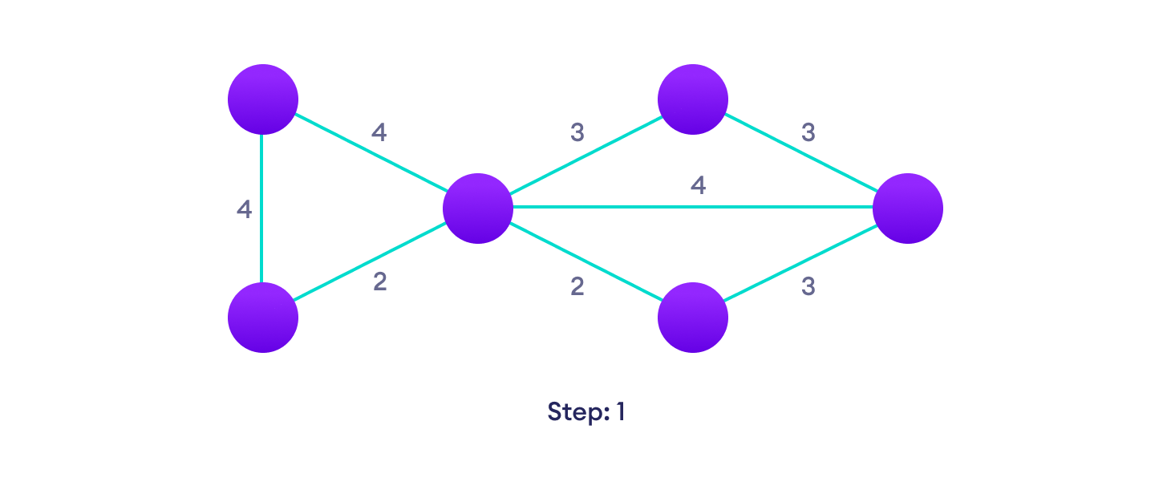Start with a weighted graphChoose the edge with the least weight, if there are more than 1, choose anyoneChoose the next shortest edge and add it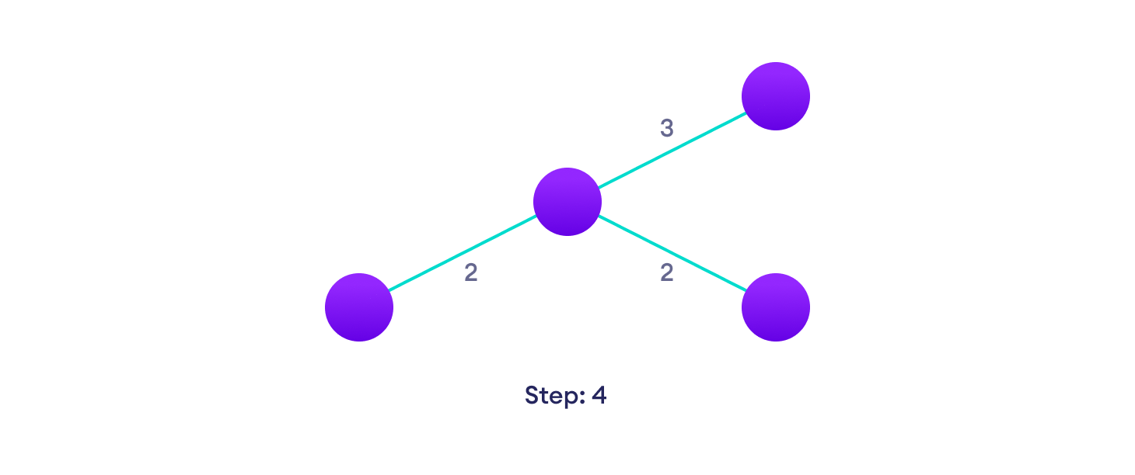Choose the next shortest edge that doesn't create a cycle and add it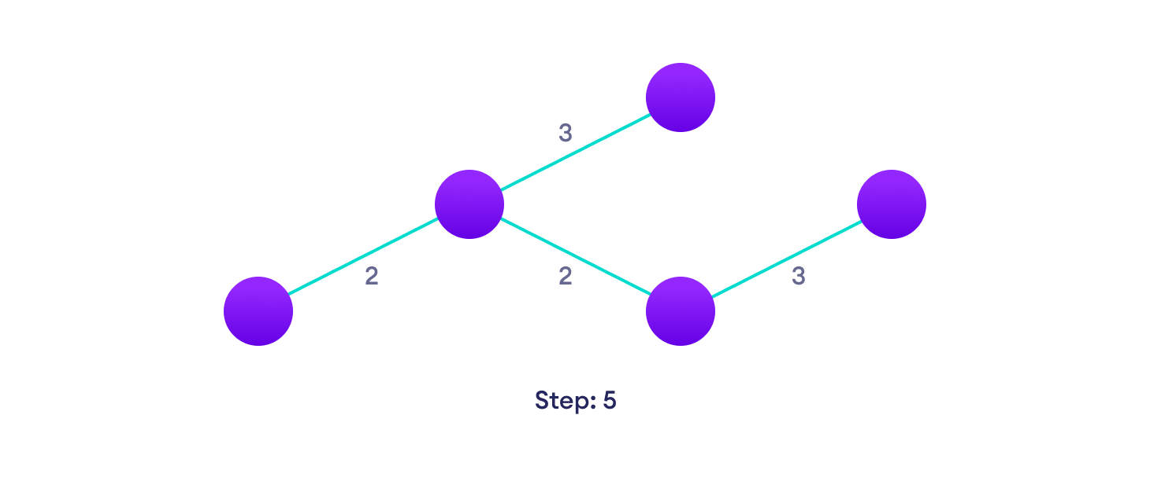Choose the next shortest edge that doesn't create a cycle and add it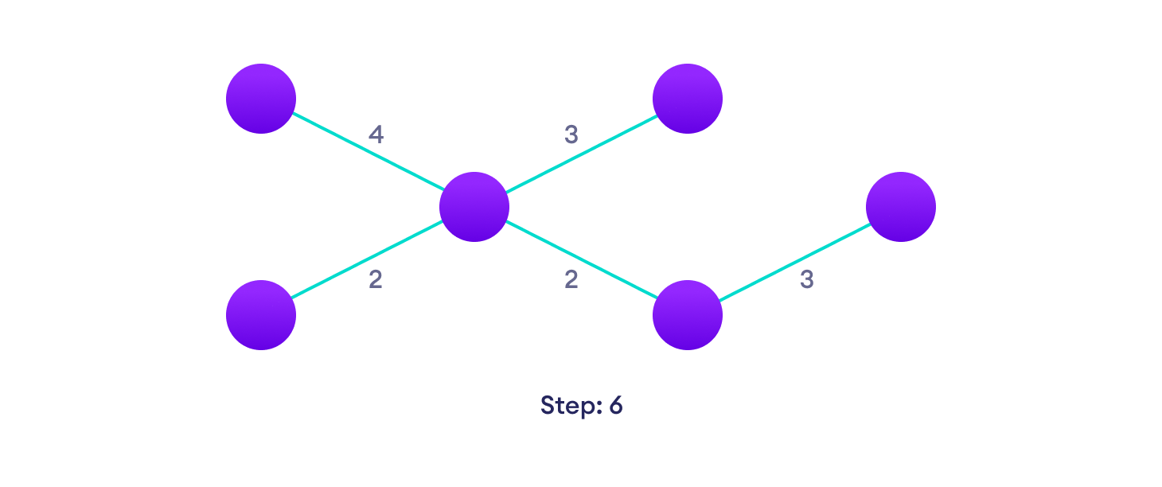Repeat until you have a spanning tree

## **Kruskal Algorithm Pseudocode**

Any minimum spanning tree algorithm revolves around checking if adding an edge creates a loop or not.

The most common way to find this out is an algorithm called [Union FInd](https://www.cs.duke.edu/courses/cps100e/fall09/notes/UnionFind.pdf). The Union-Find algorithm divides the vertices into clusters and allows us to check if two vertices belong to the same cluster or not and hence decide whether adding an edge creates a cycle.

KRUSKAL(G):

A = ∅

For each vertex v ∈ G.V:

MAKE-SET(v)

For each edge (u, v) ∈ G.E ordered by increasing order by weight(u, v):

if FIND-SET(u) ≠ FIND-SET(v):

A = A ∪ {(u, v)}

UNION(u, v)

return A

## **Kruskal's vs Prim's Algorithm**

[Prim's algorithm](https://www.programiz.com/dsa/prim-algorithm) is another popular minimum spanning tree algorithm that uses a different logic to find the MST of a graph. Instead of starting from an edge, Prim's algorithm starts from a vertex and keeps adding lowest-weight edges which aren't in the tree, until all vertices have been covered.

## **Kruskal's Algorithm Complexity**

The time complexity Of Kruskal's Algorithm is: O(E log E).

## **Kruskal's Algorithm Applications**

* In order to layout electrical wiring
* In computer network (LAN connection)